Alpha - Version
Requirements Gathering Template
Project Overview

Project Manager: Bhekabona Mbhele
Project: Batch Mixer Report System
Plant: High Chrome Ball Plant
Version: 1.0.0.0
Prepared by: Tsundzukani Nkuna
From Date: 2025/ 06/ 25 To Date: 2025/ 06/ 26
Project Objectives: The objective of the project is to provide easy and convenient access to the sand batch records across the three casting sections at High Chrome Ball Plant.

Table of Contents
INTRODUCTION 1
BUSINESS REQUIREMENTS 1
1.1 Business Goals: 1
BUSINESS RULES 2
2.1 Data Integrity & Validation 2
2.2 Access & Permissions 2
2.3 Time & Date Constraints 2
2.4 System Availability 2
2.5 Performance & Responsiveness 2
FUNCTIONAL REQUIREMENTS 3
3.1Use Cases and Use Stories Figure 3
3.1.1 Use Case 01: View Line 1 Sand-Batch Report 3
3.1.2 Use Case 02: View Line 2 Sand-Batch Report 3
3.1.3 Use Case 03: View Line 3 Sand-Batch Report 3
3.2 Business Use Cases and Business Use Stories 4
3.2.1 Business Case 01: Filter by Production Line 4
3.2.2 Business Case 02: Filter by Date and Time 4
3.2.3 Business Case 03: Export to Excel 4
3.3 System Use Cases and System Use Stories 5
3.3.1 System Case 01: Display Daily, Monthly and Yearly Total 5
3.3.2 System Case 02: Display Minimum and Maximum of Sand Batch Type 5
3.3.3 System Case 03: Display Each Total Batches 6
BUSINESS AND SYSTEM FEATURES 6
4.1 Business Feature 1: Filter by Date and Time 6
4.2 Business Feature 2: Filter by Production Line 6
4.3 Business Feature 3: Export to Excel 6
4.4 System Feature 4: Display Daily, Monthly and Yearly Total 6
4.5 System Feature 5: Display Minimum and Maximum of Sand Batch Type 6
4.6 System Feature 5: Display Each Total Batch 7
DATA REQUIREMENTS 7
5.1 Data Input 7
5.2 Data Output 7
5.3 Data Storage 7
NON – FUNCTIONAL REQUIREMENTS 8
6.1 Performance 8
6.2 Security 8
6.3 Scalability 8
6.4 Availability 8
USABILITY REQUIREMENTS 9
USER INTERFACE (UI) REQUIREMNTS 9
TECHNICAL REQUIREMNTS 9
9.1 Platform 9
9.2 Technology Stack 9
9.3 Integration 9
RISKS 10
10.1 Identified Risks 10
10.2 Risk Mitigation Strategies 10
CONSTRAINT AND ASSUMPTIONS 10
11.1 Timeline 10
11.2 Resources 10
11.3 Assumptions 10
APPROVAL AND SIGN -OFFS 11

INTRODUCTION
This Requirements Gathering Template defines the foundational elements of the Batch Mixer Report System – Alpha Version, intended for implementation at the High Chrome Ball Plant. This system marks a critical advancement in the plant’s digital transformation strategy, with a focus on enhancing the traceability, and accessibility of sand batching operations data.
Under the guidance of Project Manager Bhekabona Mbhele and technical ownership by Tsundzukani Nkuna, the initiative aligns with the broader operational objective of enabling real-time monitoring, quality assurance, and production traceability across Lines 1, 2, and 3. This alpha release outlines the initial requirements that support key process automation, particularly in data acquisition, batch composition analysis, and report generation.

BUSINESS REQUIREMENTS

1.1 Business Goals:
The Batch Mixer Report System for the High-Chrome Ball Plant is being developed to automate the collection, storage, and presentation of sand-batch data from Line 1, Line 2, and Line 3. For each sand batch produced on a given day, the system will record:
- Batch number,
- Date and time of mixing,
- Quantities of return sand, bentonite and coal dust added, and amount of water used in mixing each batch.

BUSINESS RULES
The following business rules and constraints will govern the functionality, access, and operational logic of the Batch Mixer Report System.

2.1 Data Integrity & Validation
- The system stores all batch records processed through the Sand plant Scada, for each casting line.
- The data accuracy, that is recorded through the Sand plant PLC and Scada is dependent on the scale’s standardization.
- Duplicate entries for the same Lines, date, and time must be filtered in the final app report.

2.2 Access & Permissions
- The app has no access limitations.
- End-users can view and export data only, no edits are made possible to the information presented in the app.
- Managers and Technicians can upload, edit, and annotate results before final validation.
- Engineers have read-only access to the reports accessed in the app.
- The report can be extracted into excel format, for further processing.

2.3 Time & Date Constraints
- Sand-Batch Report records must include both date and time stamps for traceability.
- Entries older than 5 years may be archived but not deleted

2.4 System Availability
- The system must be accessible during standard plant operating hours (24/7), with scheduled downtime communicated 24 hours in advance.
- Automatic backups of all Sand-Batch Report data must occur every 24 hours.

2.5 Performance & Responsiveness
- The system should retrieve and display query results within 3 seconds for normal data ranges.
- The system presents past day batch records, timed as 7H00 to 7H00.

FUNCTIONAL REQUIREMENTS

3.1Use Cases and Use Stories Figure
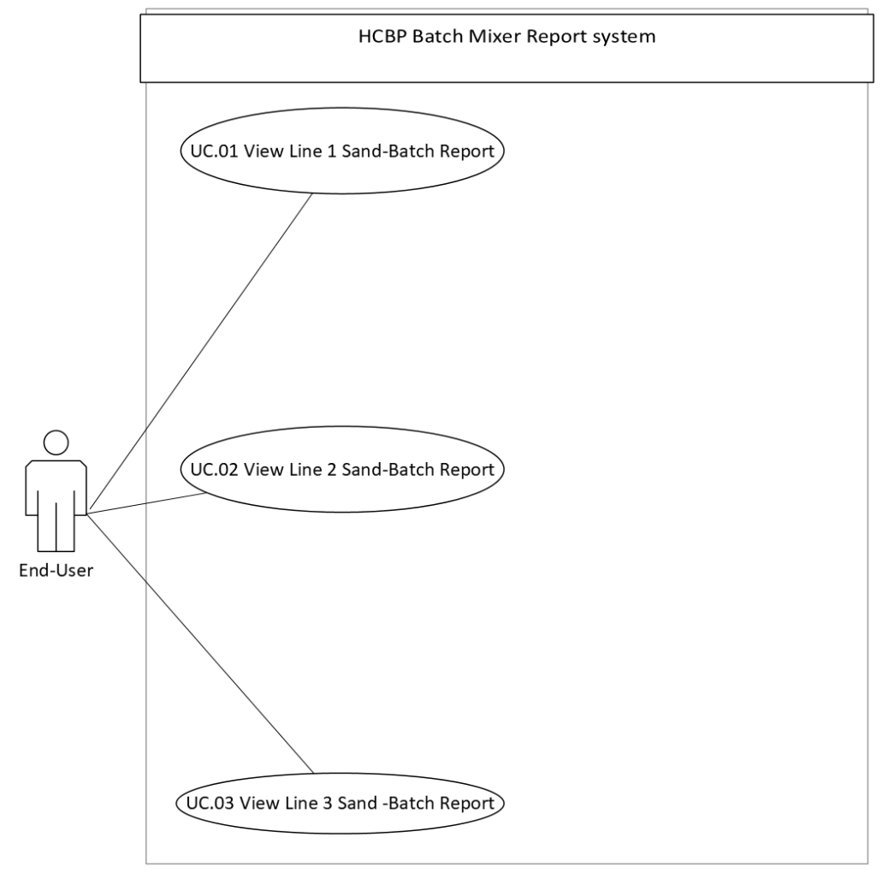

3.1.1 Use Case 01: View Line 1 Sand-Batch Report

As a user, I want to view the latest Sand Batch Report generated by the Sand Mixer on Line 1, so that I can continuously monitor and ensure production quality.

3.1.2 Use Case 02: View Line 2 Sand-Batch Report

As a user, I want to view the latest Sand Batch Report generated by the Sand Mixer on Line 2, so that I can continuously monitor and ensure production quality

3.1.3 Use Case 03: View Line 3 Sand-Batch Report
As a user, I want to view the latest Sand Batch Report generated by the Sand Mixer on Line 3, so that I can continuously monitor and ensure production quality

3.2 Business Use Cases and Business Use Stories
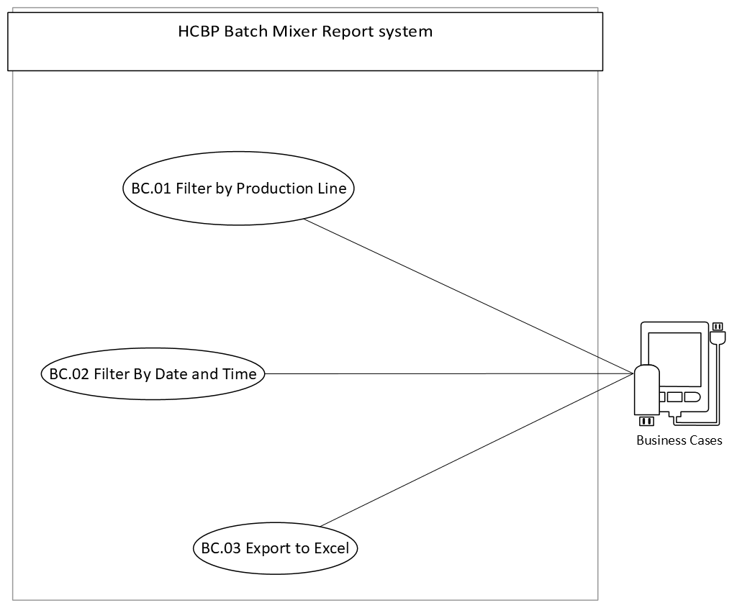

3.2.1 Business Case 01: Filter by Production Line
As a Business User, It Should allow a User to filter Sand Batch Reports by production line, so that they can quickly locate specific entries for validation or export.

3.2.2 Business Case 02: Filter by Date and Time

As a Business User, It Should allow a User to filter Sand Batch Reports by date and time, so that they can quickly find specific entries for validation or export.

3.2.3 Business Case 03: Export to Excel

As a Business User, it should allow exporting Sand Batch Report results to .xlsx format, so that users can easily document and share the data for review and compliance.

3.3 System Use Cases and System Use Stories
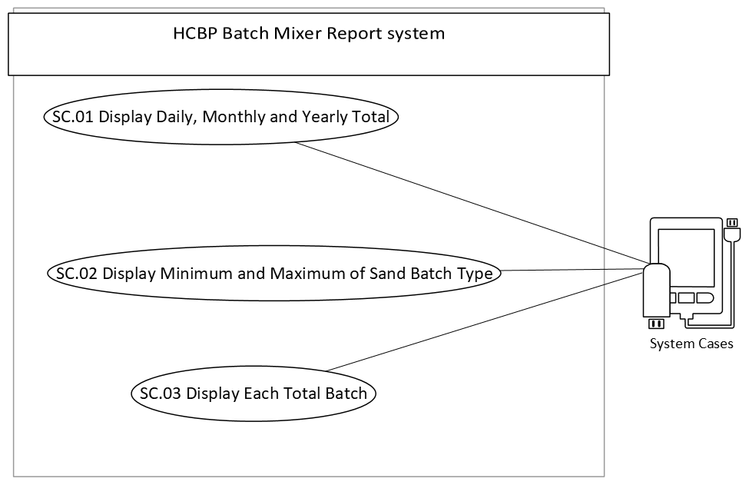

3.3.1 System Case 01: Display Daily, Monthly and Yearly Total
As a System, It Should Display the Daily, Monthly and Yearly of Sand Report per production line and Filtered by Date and Time, so that they can quickly monitor Daily, Monthly and yearly entries Difference for validation.

3.3.2 System Case 02: Display Minimum and Maximum of Sand Batch Type
As a System, It Should Display the Minimum and Maximum of Sand Batch Type per production line and Filtered by Date and Time, so that they can quickly locate specific Min or Max entries for validation.

3.3.3 System Case 03: Display Each Total Batches
As a System, It Should Display Total of Each Sand Batch Type per production line and Filtered by Date and Time, so that they can quickly locate specific Average entries for validation.

BUSINESS AND SYSTEM FEATURES

4.1 Business Feature 1: Filter by Date and Time
- Description: The system provides filtering capabilities by Date and Time ranges.
- Purpose: To allow users to retrieve historical or time-specific data entries.
- Inputs: Start and end date/time values.
- Output: Filtered Sand-Batch Report that fall within the specified time window.

4.2 Business Feature 2: Filter by Production Line
- Description: The system allows users to Filter Sand-Batch data by Line Number.
- Purpose: To focus the analysis or review process on a specific Production Line.
- Inputs: Selected Production Line from a dropdown or filter option.
- Output: Records related to the selected Production Line only.

4.3 Business Feature 3: Export to Excel
- Description: The system supports exporting filtered or full Sand-Batch data to Excel (.xlsx) format.
- Purpose: To facilitate easy sharing, archiving, or further offline analysis.
- Trigger: Clicking the “Export to Excel” button.
- Output: Downloadable .xlsx file with Batch Sand records and applied filters.

4.4 System Feature 4: Display Daily, Monthly and Yearly Total
- Description: The system Display the Daily, Monthly and Yearly Total of Sand Report.
- Purpose: To allow users to read historical Total of Sand Report.
- Inputs: Selected Production Line and Date and Time Ranges.
- Output: Filtered Sand-Batch Report that fall within the specified time window.

4.5 System Feature 5: Display Minimum and Maximum of Sand Batch Type
- Description: The System Display the Maximum and Minimum of Sand Batch Type.
- Purpose: Review process on the minimum and maximum of Sand Batch Type.
- Inputs: Selected Production Line from a dropdown and Date and Time Ranges.
- Output: Minimum and Maximum of Sand Batch Type.

4.6 System Feature 5: Display Each Total Batch
- Description: The System Display Each Total Batches.
- Purpose: Review Each Batch Total.
- Inputs: Selected Production Line from a dropdown and Date and Time Ranges.
- Output: Each Batch Total.

DATA REQUIREMENTS

5.1 Data Input
The following data is automatically saved to the HCBP-SQL-server from the Scada, and thereafter warehoused in AUT-ENG database:
- Sample Metadata:
  - Date and Time
  - Batch Number
  - Bentonite
  - Coal Dust
  - New Sand
  - Water
  - Return Sand
- User Inputs for Filtering and Search:
  - Production Line Selection (Drop-down menu)
  - Date and Time range selection

5.2 Data Output
The system will produce and display the following output data:
- Filtered Mixer Sand-Batch Results based on user-specified criteria
- Tabular Results displayed in a ASP.Net Web-based Portal (e.g., Table)
- Exportable Files:
  - XLSX files for full or filtered datasets

5.3 Data Storage
- Primary Storage: SQL Server Database (AUT-ENG\GM_PRODUCTION)
  - Table:
      - Mixer Line 1
      - Mixer Line 2
      - Mixer Line 3
- Backup Policy:
  - Automatic backup of the database every 1 Month
- Security & Integrity:
  - All data is access-controlled via role-based permissions.
  - Input is validated to prevent abnormal or out-of-bound entries.

NON – FUNCTIONAL REQUIREMENTS

6.1 Performance
- The system must load filtered data queries within 15 seconds.
- The system must support concurrent access by at least 50 users without performance degradation.
- Export functions (XLSX/PDF) must complete within 5 seconds under normal load.

6.2 Security
- Data Transmission: All data transmitted between client and server must be secured.
- Access Control: Granular permissions by Instruments (e.g., only Instrumentation can verify/reject Sand-Batch Report).
- Data Protection: Stored data must be protected against unauthorized access, tampering, or deletion.

6.3 Scalability
- The system should be designed to scale horizontally with minimal configuration changes.
- Support for future data growth, including:
  - More Production Lines (beyond Line 1, Line 2 and Line 3)
  - Additional Sand-Batch Report types or plants

6.4 Availability
- The system must be available at least 99.75% of the time during business hours (24/7 preferred for plants running continuously).
- Database and application services should be backed up with a disaster recovery plan.

USABILITY REQUIREMENTS
- Minimal Training: The system should be easy to use with little to no training required for basic functions.
- Fast Load Times: Data should display within 2 seconds for common filters.
- Accessibility: Ensure readability (font size, contrast) and proper tab order for keyboard navigation.
- Error Handling: User-friendly error messages for invalid inputs or connection issues.
- Consistency: Uniform design and behaviour across all pages and features.

USER INTERFACE (UI) REQUIREMNTS
- Responsive Design: The Web Portal interface must be usable on Chrome or Microsoft Edge.
- Intuitive Layout: Clear navigation with minimal clicks to access key functions.
- Search & Filter Panel: Prominent and easily accessible filters (Date Time and Production Line).
- Table Format: Display Sand-Batch results in a structured, sortable table.
- Export Buttons: Clearly labelled options for "Export to Excel".

TECHNICAL REQUIREMNTS

9.1 Platform
- The system will run on:
  - Microsoft Edge / Google Chrome
  - SQL Server for database backend
  - Accessible via IIS (Internet Information Services)

9.2 Technology Stack
- Backend: ASP.NET (Web) with C#
- Frontend: Asp.net
- Database: Microsoft SQL Server

9.3 Integration
- AUT-ENG\GM_PRODUCTION System: For real-time and historical data access.
- Production Line Equipment.
- Direct data ingestion from Scada / PLC.

RISKS

10.1 Identified Risks
- Incomplete or inconsistent data from Instrumentation equipment.
- Downtime of AUT-ENG\GM_PRODUCTION affecting data access.
- Unexpected data volume growth impacting performance.
- Sand plant Scada downtime or off the network.
- HCBP-SQL-SERVER offline or downtime.

10.2 Risk Mitigation Strategies
- Implement validation rules to catch and flag incomplete data.
- Conduct user training and demos to ease adoption.
- Design the system with offline caching fallback (if needed).
- Optimize queries and prepare archiving strategies for old data.

CONSTRAINT AND ASSUMPTIONS

11.1 Timeline
- Development Start: 25 June 2025
- Testing Phase: Frequently after Updates
- Go-Live: Frequently after Updates approval

11.2 Resources
- Team:
  - MIS Technician
- Technology:
  - IIS (Internet Information Services)
  - SQL Server
  - ASP.NET stack

11.3 Assumptions
- SQL Server and Visual Studio are already set up and configured.
- The reporting needs will remain relatively stable post-launch.
- Users have basic computer literacy and can operate Excel and PDF tools.

APPROVAL AND SIGN -OFFS
Name: Bhekabona

Signature: Bhekabona Mbhele

Date: 26 – June -2025

